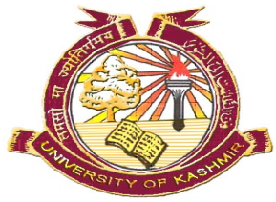
P. G. Department of Political Science
UNIVERSITY OF KASHMIR
Hazratbal, Srinagar – 190006
Head of the Department

No: F (Ph.D Admission-Pls) KU/18
Dated: 03-10-2018

Notice
A Departmental Research Committee (DRC) meeting will be held on 10th October, 2018 at 11:00 am in the office chamber of the undersigned for the counseling of the candidates who have applied for admission M. Phil/Integrated & Ph. D admission for the year 2018. The candidates who have submitted documents in the department are hereby informed to attend the counseling along with all relevant certificates (Original) on scheduled date in the department.
s/d
Head of the Department
Copy to:-
- DRC, Members are requested to attend the meeting on scheduled date and time.
- Departmental Website.
- Notice Board.

